PHASE 6 – USER INTERFACE DEVELOPMENT

Lightning App Builder Implementation
- Student Record Page
A custom Student Record Page was created using Lightning App Builder to display student-related information in a structured manner.
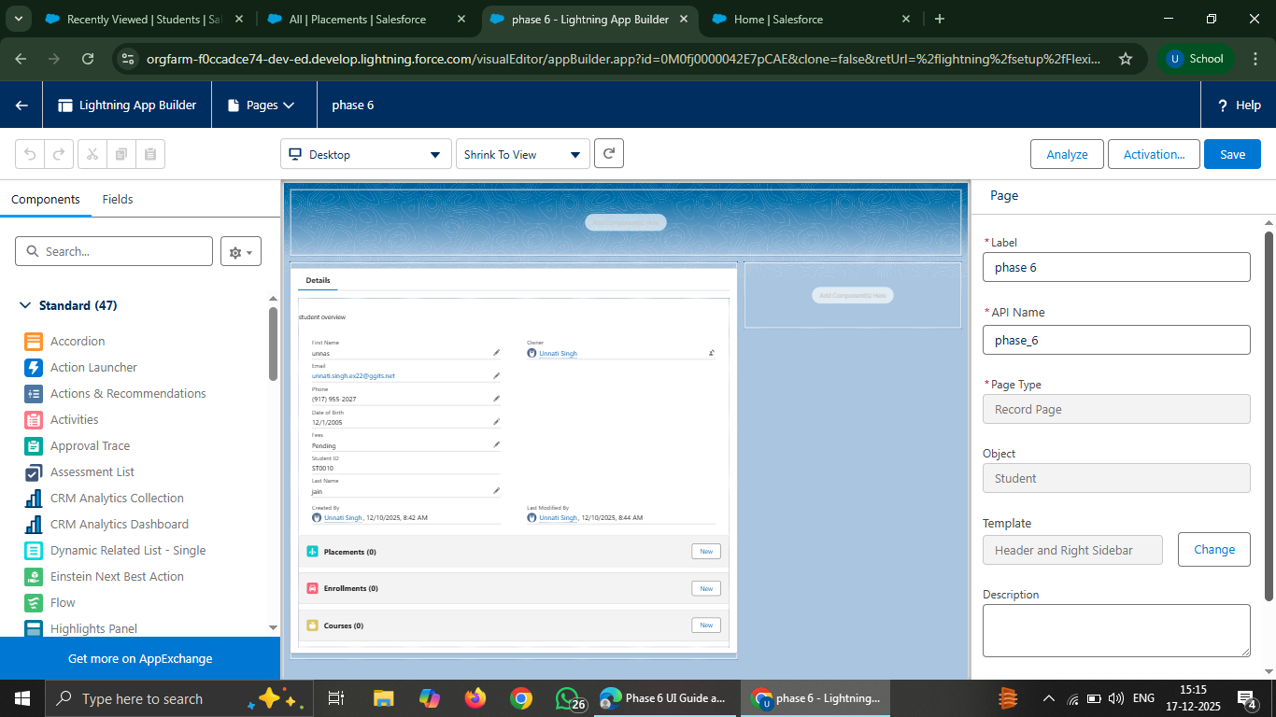
- Tabs and App Navigation
The existing Student CRM App was enhanced by organizing navigation tabs.
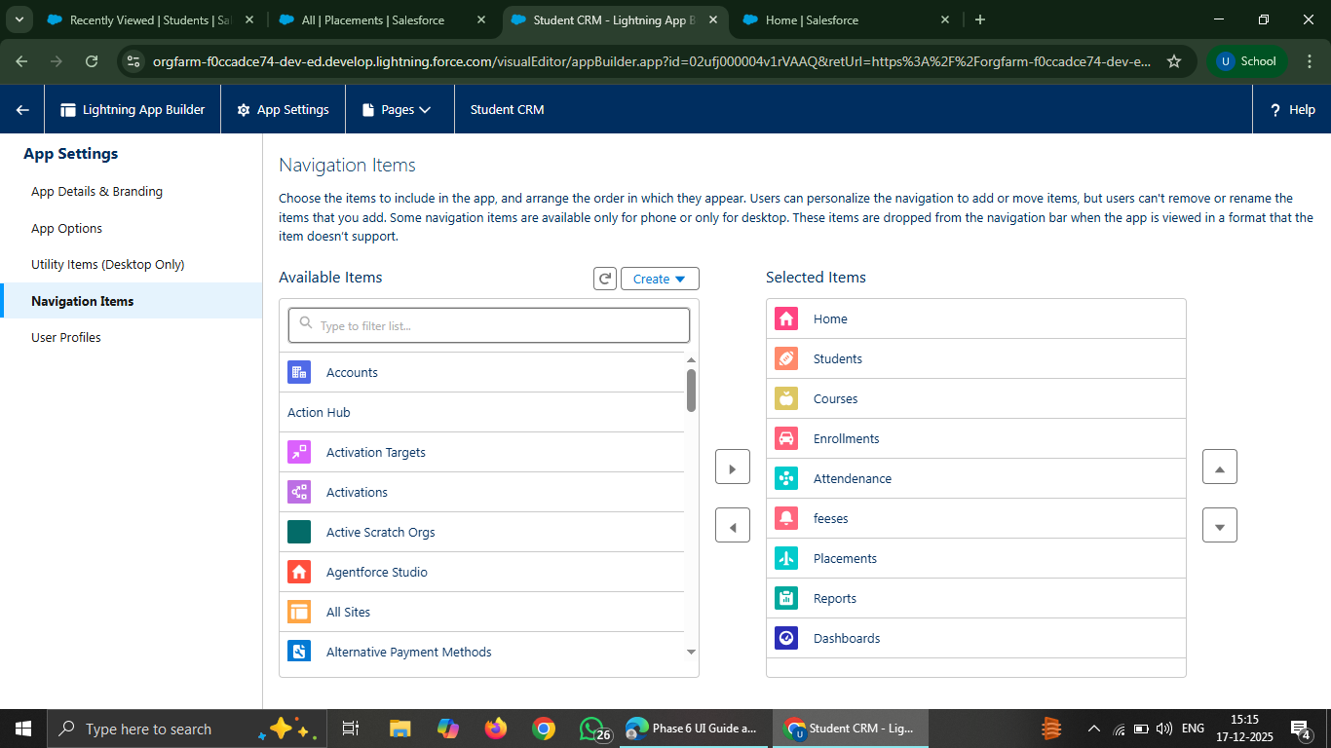
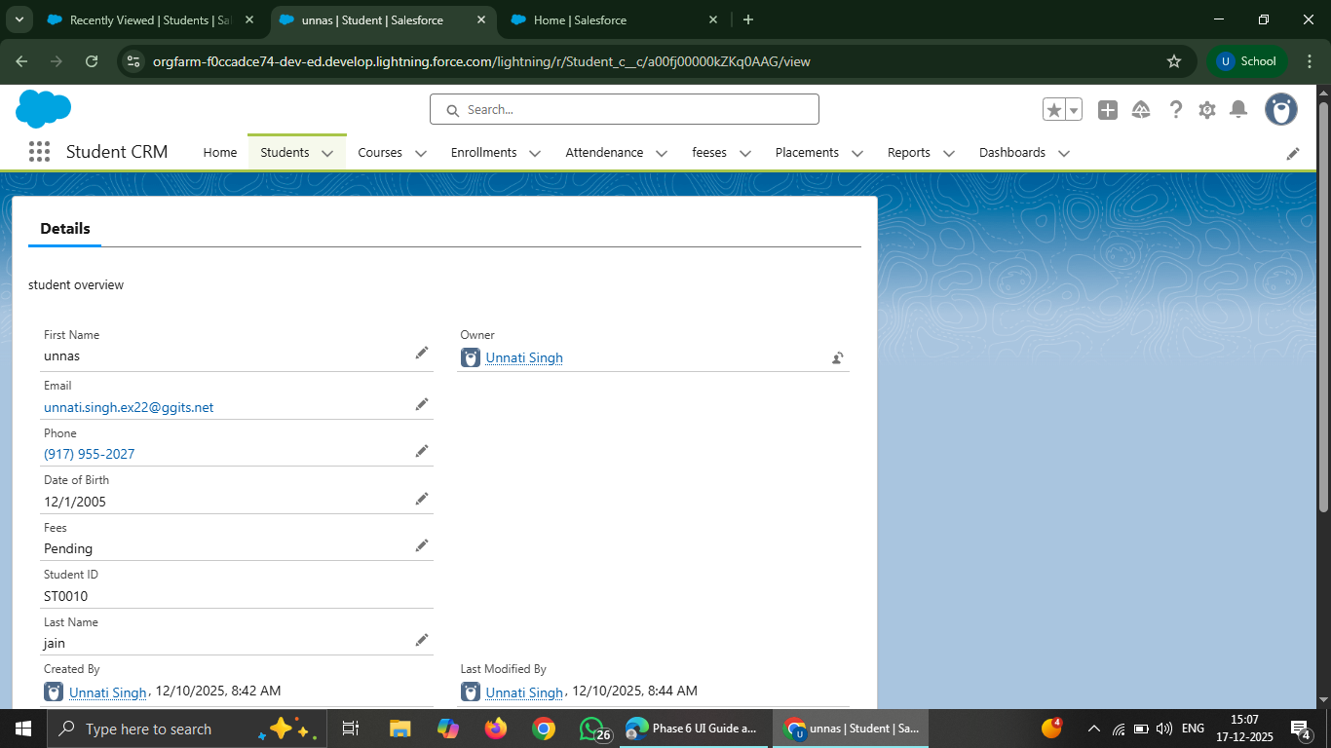

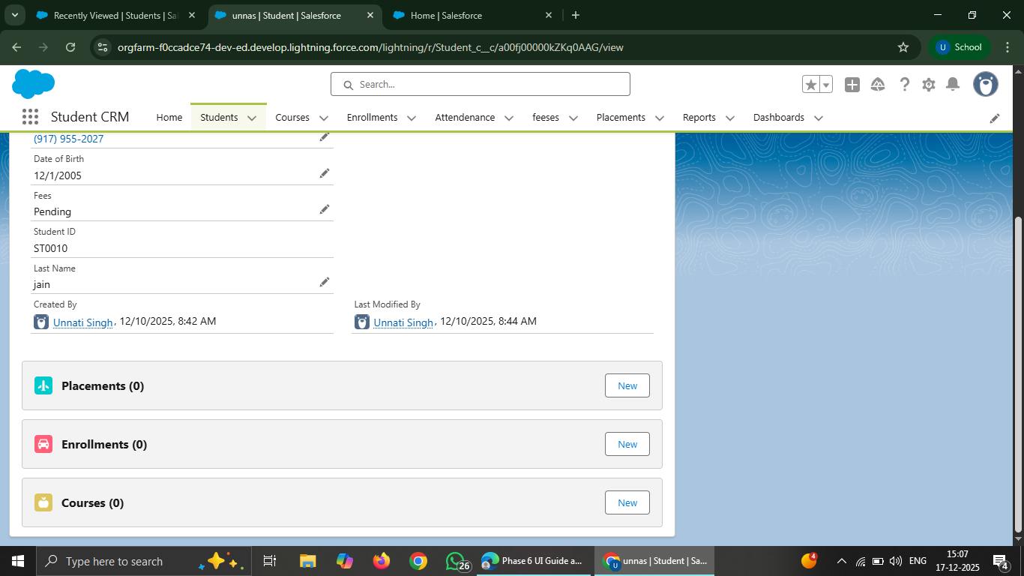

- Home Page Customization
A custom Home Page was created using Lightning App Builder with the Standard Home Page template.
- Components added:
Welcome message using Rich Text
List View showing recent student records
Report charts for student data
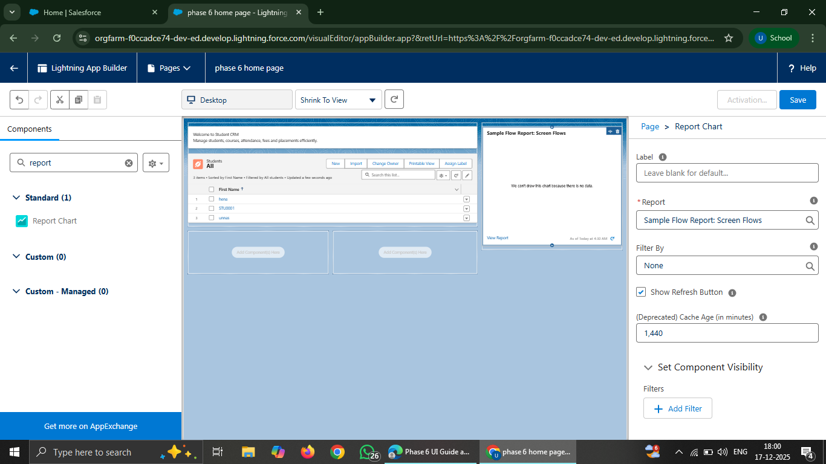

- Utility Bar Configuration
The Utility Bar was configured in the Student CRM App to enhance productivity.
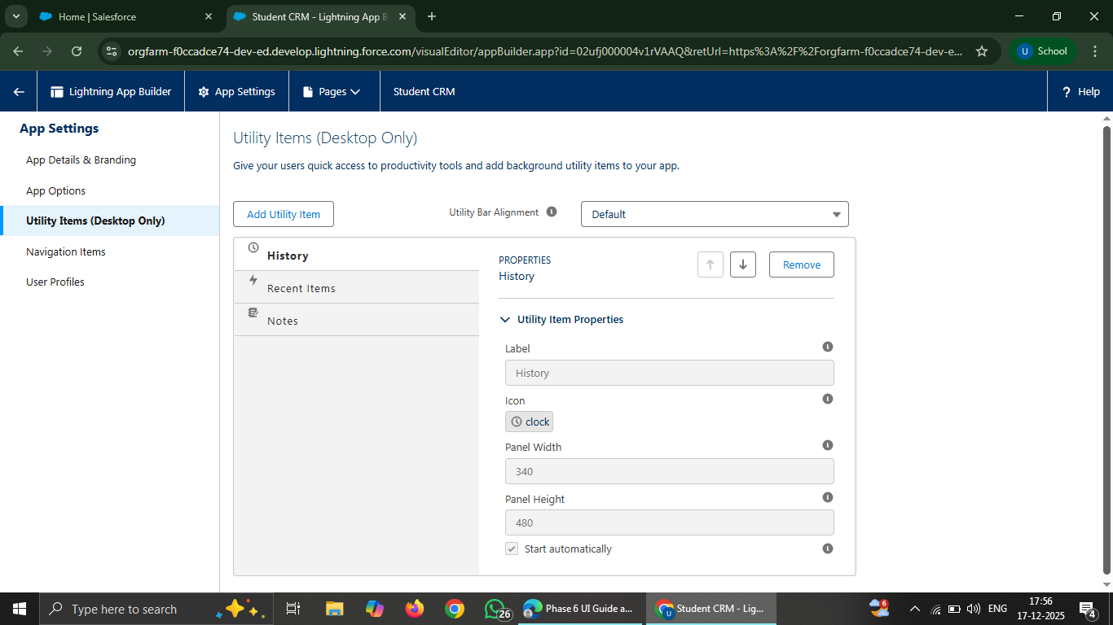
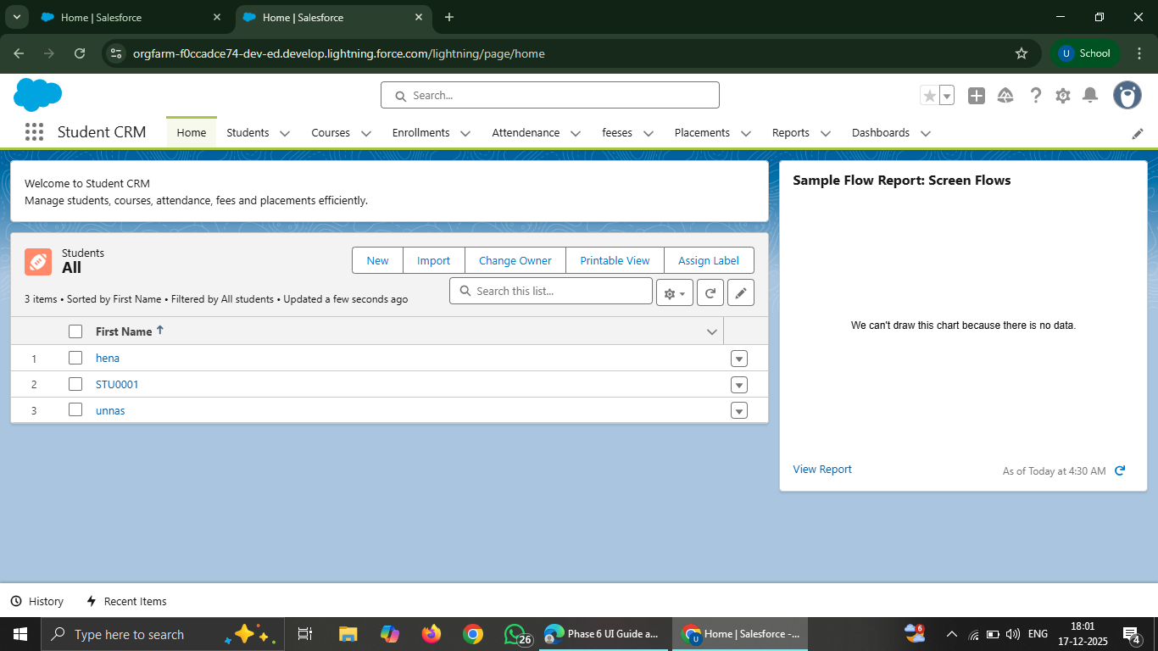

- Lightning Web Components
A Lightning Web Component was designed conceptually to display a Student Summary Card on the Student Record Page.
- Key concepts covered:
Apex integration using @AuraEnabled
Record-based data retrieval
Use of wire adapters (conceptual understanding)
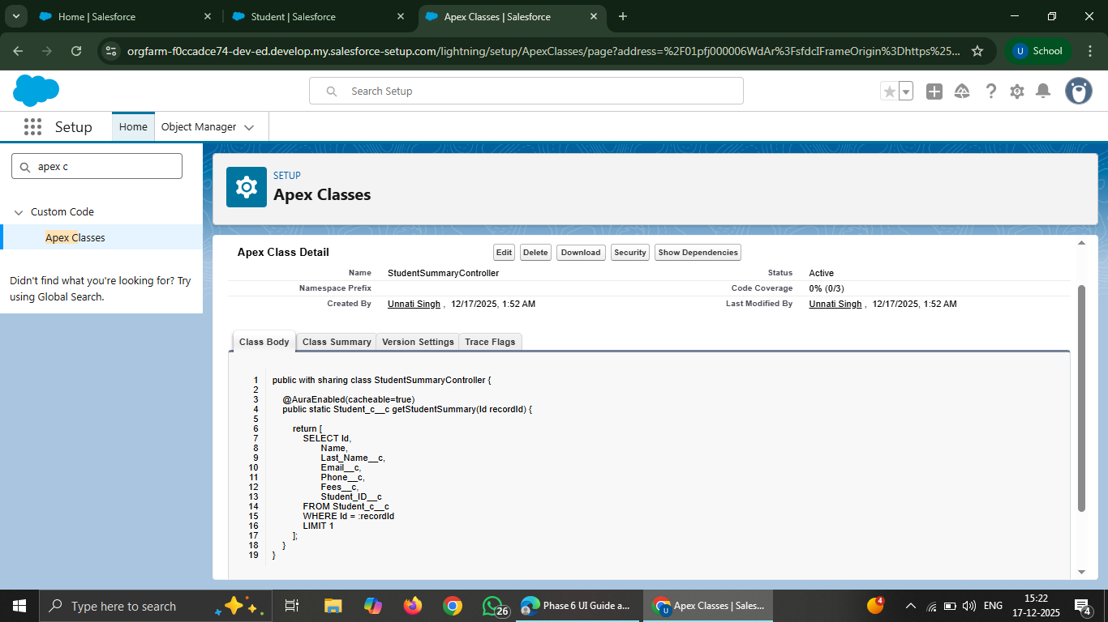

Due to org-level configuration and feature availability limitations in the current Salesforce environment, direct creation and deployment of LWCs through the Setup UI was not accessible.
- Despite this limitation:
- The LWC architecture and Apex integration approach were clearly understood and designed.
- UI requirements were successfully fulfilled using standard Lightning components.
- The overall Phase 6 objectives related to UI enhancement and usability were achieved.

The project remains fully extensible, and Lightning Web Components can be implemented in the same design once the required development access is available.

